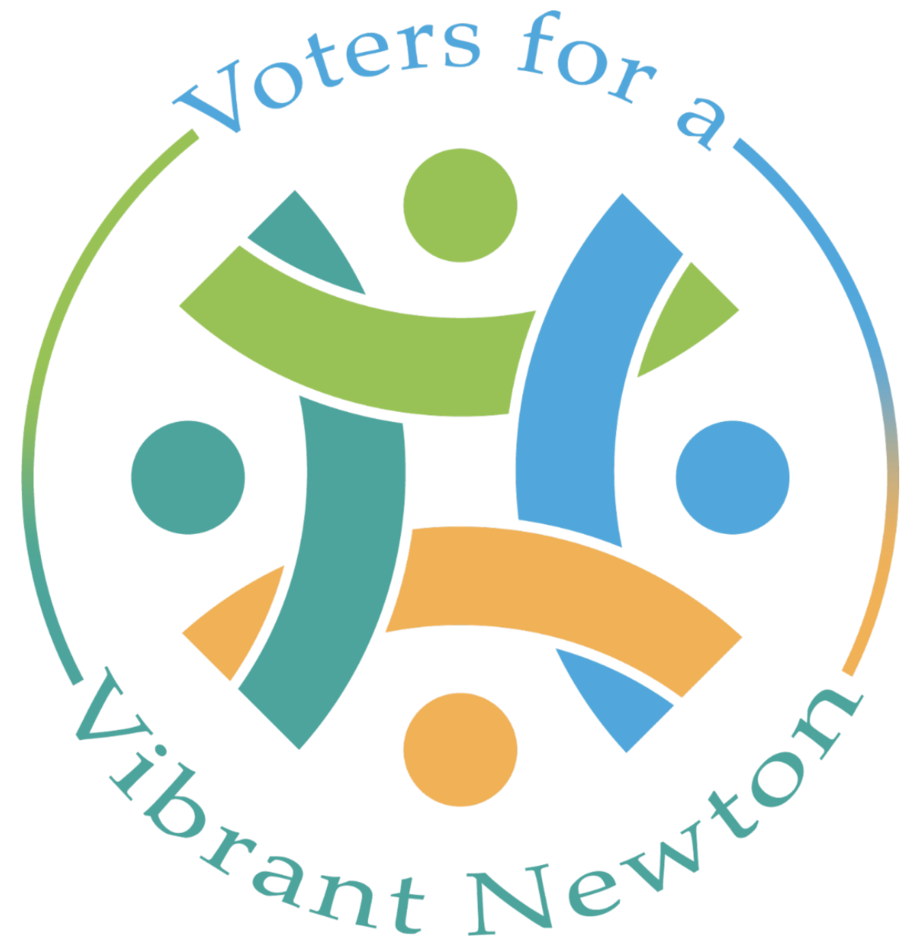

Voters for a Vibrant Newton PAC 2023 City Council Questionnaire
Thank you for completing the 2023 Voters for a Vibrant Newton PAC candidate questionnaire. To submit your answers, email a PDF of your answers by August 15th. Responses to this questionnaire will inform our endorsement decisions and will be posted online. Please limit each answer to 150 words.

Candidate Name: Vicki Danberg
Candidate for City Councilor At Large, Ward 6

1. What do you see as the key elements of a vibrant village center?

Newton's village centers have suffered the loss of many local businesses over the last 30 years. COVID made things worse and caused business losses yet unrecovered.

Our village centers need housing in order to stay vibrant in the coming decades. Newton lacks all levels of housing, especially that for young families, City employees, downsizers and seniors who live in larger homes who want to stay in the City they love but have nowhere to go.

Newton has come a long way toward welcoming more restaurants and other businesses, but has lost many local businesses that require a local clientele to survive. We could turn this around by adding housing into our villages to provide customers for local business.

Our seniors who would like to downsize and those with mobility issues look for buildings with elevators to serve their needs. We must create housing in our villages that serves everyone's needs.

2. What do you think of the current proposal for Village Center Zoning Redesign? (Please specify strengths and shortcomings.)

The Zoning and Planning Committee began work on its revised ordinance for village centers in early 2021. It is a collaborative effort among Council, staff, consultants and the community designed to support our community vision of helping local business, respond to climate change, encourage diverse and affordable housing and create more active communal spaces.

Its intent is to foster development appropriate to our village centers and surrounding neighborhoods in keeping with the City's Comprehensive Plan and bring housing into our village centers. Current zoning also does not recognize the uniqueness of Newton's dynamic and diverse villages. The proposal has made a big effort to do so.

The proposal strives to promote a lively pedestrian environment and a variety of local businesses that serve the needs of the community, expand housing options, create a sense of place and facilitate compliance with the MBTA communities requirement.

I feel that the proposal is a great improvement over the current zoning code and meets many of the above stated goals.

3. What steps would you take to encourage more varied and locally owned businesses in Newton?

We need to make the process for new and existing local business less cumbersome, time consuming and expensive.

A new restaurant had to submit an additional plan for seating "pre-special permit" with time delay and added expense. Such practices are overly burdensome to small businesses. Current village commercial parking requirements are burdensome and costly for local businesses. I support no village commercial parking requirement.

The "Use Table" enumerating allowed businesses is badly out of date and finally undergoing an overhaul. Brew pubs, Irish step dancing, coding businesses and more likely new businesses are not on the list nor is BYOB. Other communities allow it. Why not us?

Outdoor dining privileges are still under extended COVID rules. We need to allow restaurants to have popular outdoor dining tables without removing indoor dining to compensate and without special permit time delay and expense.

We need to cure business from seeing government as something done to them and instead, as an encouraging and helpful partner in their quest to bring needed services and products to the community.

4. What are your ideas for increasing economic and racial diversity in Newton?

Expand affordable housing: Newton's shortage of affordable housing creates a barrier for middle and low income families to live here. More affordable housing will make Newton more accessible to people from all socioeconomic and racial backgrounds.

Recruit more diverse teachers and staff to create a more inclusive environment for children of all backgrounds.

Promote diversity awareness and provide mini-grants to small business: Create educational programs and continue hosting multicultural events.

In addition to our diversity officer, we could create a diversity task force to take a deeper dive into diversity issues and report to the Mayor.

5. What actions would you support on the City Council to make Newton more environmentally sustainable?

Newton has an ambitious Climate Action Plan that I strongly support that provides a blueprint for carbon neutrality by 2050. About 88% of Newton's GHG emissions are from energy demands in private/commercial sectors for buildings, electricity and transportation. The remaining 12% comes from municipal operations (3%), natural gas leaks (8%) and waste disposal.

Among its recommendations that Council has control over are: To require all new construction to meet Passive House standards, require HERS ratings disclosure in RE transactions, eliminate commercial parking minimums, mandate many more City and private development EV charging stations and require that an electrical option be considered for all heating system installations.

I will support any legislation that incentivizes homeowners and developers to achieve lower than average energy consumption, reduces barriers to adopting GHG emission reduction measures or otherwise puts us on a path to reducing our carbon footprint.

I supported allowing exterior insulation, heat pumps, and other energy saving devices to be installed within setbacks without requiring a special permit or variance to encourage their addition to projects, especially in retrofitting older buildings.

6. Please add anything you have not mentioned that you would like us to know about your experience, vision for Newton, etc. (150 words

I was a lead proponent of Newton's plastic bag ban, led the successful polystyrene (Styrofoam) ban and supported the "nip" bottle ban. I chair the Plastics Reduction Working Group seeking to ban toxic and non-re-cyclable black plastic food containers and a separate item seeking to ban single use plastic water bottles. I support increased composting, commercial recycling efforts, solar on roofs and the move to City and private EV vehicles.

