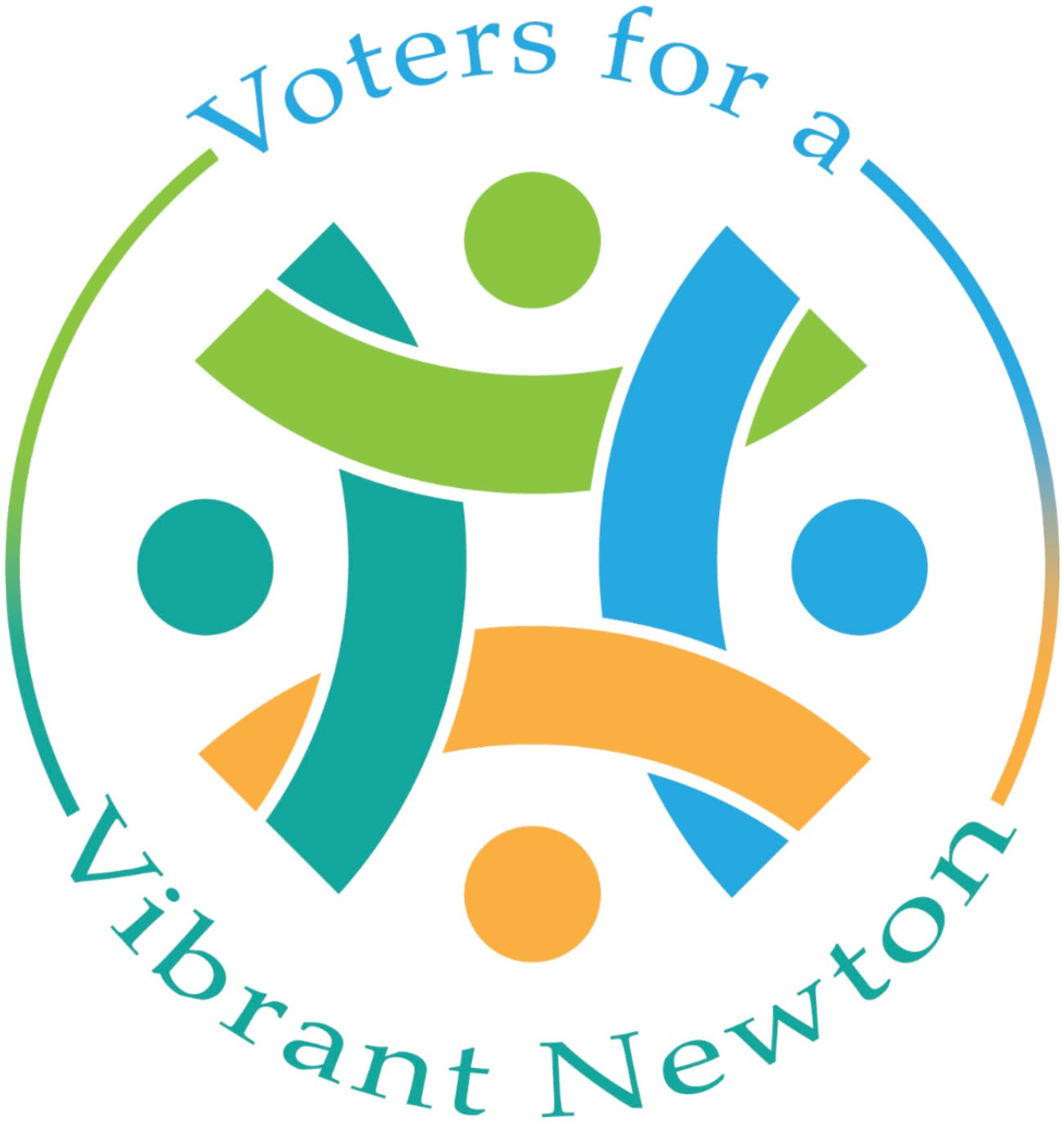

Voters for a Vibrant Newton PAC 2023 City Council
Questionnaire

Thank you for completing the 2023 Voters for a Vibrant Newton PAC candidate questionnaire. To submit your answers, email a PDF of your answers by August 15th. Responses to this questionnaire will inform our endorsement decisions and will be posted online. Please limit each answer to 150 words.

Candidate Name Doris Ann Sweet
Candidate for Ward Councilor, Ward 4

- Key Elements of a vibrant village center:

  - Open spaces and indoor venues where people can gather
  - Playground for kids
  - A variety of shops and services
  - Places to eat and drink
  - Public Transit
  - Variety of housing types and sizes, including multi-family and taller buildings, within walking distance of the center

- Current proposal for Village Center Rezoning:

  - More, and more diverse, housing is needed in Newton. The current proposal for Rezoning in Village Centers will allow for that, with multifamily housing allowed by right near transit, and conversion of larger single family homes into three or four units also allowed.

Village Center Overlay Districts are intended to create village centers that are walkable, support small businesses, and create community. I view these as strengths of Village Center Rezoning 1) by allowing more housing to be built, 2) for the environmental advantages of public transit use over private vehicle use,
3) for the environmental advantages of multi-family buildings over the same number of living units in the form of single-family homes, and 4)as well as the support for small, local businesses that village center residents will provide. The downside is that change is always hard, and some current residents will have a difficult time adjusting to changes that will, or might, occur. More assurances that changes with new zoning will take a long time to happen should be part of a strong messaging campaign.

- What steps would you take to encourage more varied and locally owned businesses in Newton

- What are your ideas for increasing economic and racial diversity in Newton?

I recently noticed an interesting and relevant piece of information from the 2019 Boston Foundation’s Greater Boston Housing Report Card. This is what caught my eye: “The Report finds communities in Greater Boston that experienced greater housing production between 2000 and 2017 experienced greater reductions in racial segregation over the same time period, and finds this association held particularly strongly for communities that produced more
multi-family housing.” This finding is an additional incentive to make it easier for developers to build multi-family homes in Newton. Economic and racial
diversity is important for the vitality of the city and for students in the schools.

- What actions would you support on the City Council to make Newton more environmentally sustainable?

    - Requiring sustainability in new construction and major renovations of buildings is an important action that should be maintained.
    - As noted above, multi-family housing is more sustainable than housing the same number of families in single family homes.
    - Making roads safer for bike travel would cut down on automobile emissions. More EV chargers in city parking lots is likely to incentivize purchase of
    - EV’s as charging is made more convenient.
    - Additional arrays of solar panels on city properties to further model a route to cleaner energy production.

- Please add anything you have not mentioned that you would like us to know about your experience, vision for Newton, etc.

As a reference librarian and library manager in college and university libraries for more than 40 years, I interacted with many students, faculty, and community members over the course of any given day, helping them define and solve research problems and find accurate information. I would use the same skills and drive to collaborate with other City Council members, City staff, and residents, to frame issues and explore solutions.

